Activity 2 – Source Analysis Worksheet

By following the links, complete the source analysis worksheet.

Source | What is it? | What does it show? | How useful/reliable is this source? | What does this source tell us about Pericles’ reign over Athens?
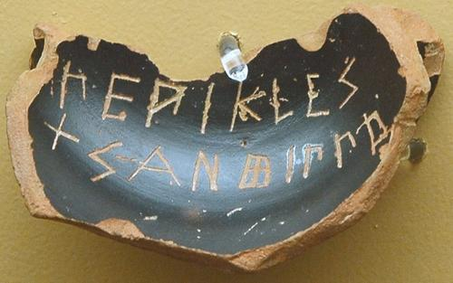
Source 1: An ostrakon against "Pericles, the son of Xanthippus"
http://www.livius.org/pen-pg/pericles/pericles.html
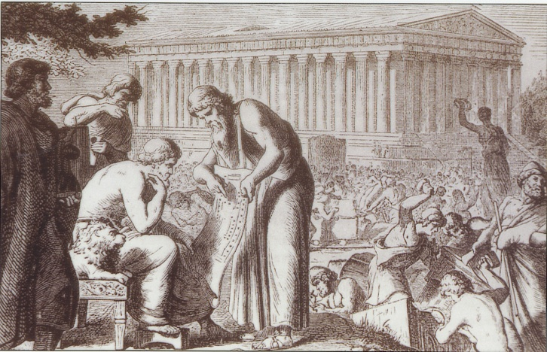
Source 2: Engraving of an architect showing a blueprint to Pericles.
http://www.mitchellteachers.org/WorldHistory/AncientGreece/Images/PericlesConstructionAthensTrans.jpg
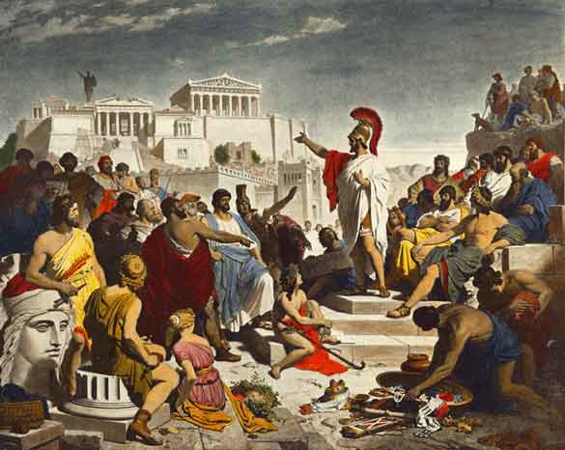Source 3: Pericles giving his funeral oration.
http://www.ancientgreekbattles.net/Pages/People/Pericles.htm
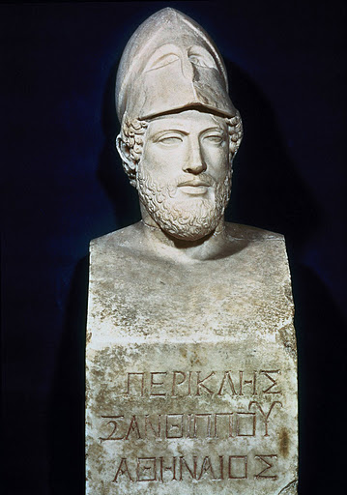
Source 4: Bust of Pericles.
http://lh3.ggpht.com/-FC-S6y15FQc/Tcik7ns0k6I/AAAAAAAAKFs/EDolByBhwiM/0541.jpg
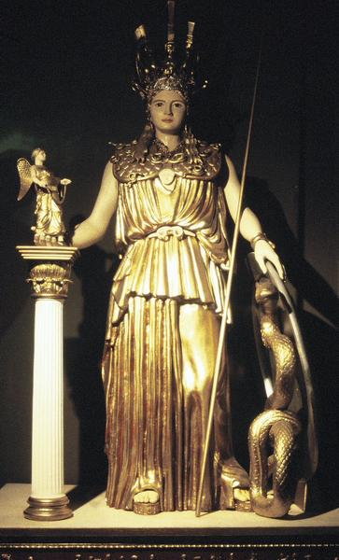
Source 5: A reconstruction of the cult statue of Athena.
http://www.livius.org/as-at/athens/athens.html

